Rockbuster Stealth



Table of Contents

Entity Relationship Diagram(ERD)…………………………………...3

Fact Table: Rental……………………………………………………....4

Dimension Table: Payment…………………………………4-5

Dimension Table: Film Actor……………………………………5

Dimension Table: Inventory……………………………………..5

Dimension Table: Actor…………………………………………..5

Dimension Table: Language……………………………………..5-6

Dimension Table: Film……………………………………………....6

Dimension Table: Film Category……………………………….....7

Dimension Table: Category……………….…………………………7

Dimension Table: Customer………………………………………..7-8

Dimension Table: Store………………………………………….…….8

Dimension Table: Staff………………………………………………..8

Dimension Table: Address………………………………………..8-9

Dimension Table: City…………………………………………………9

Dimension Table: Country……….…………………………………..9

Entity Relationship Diagram (ERD)

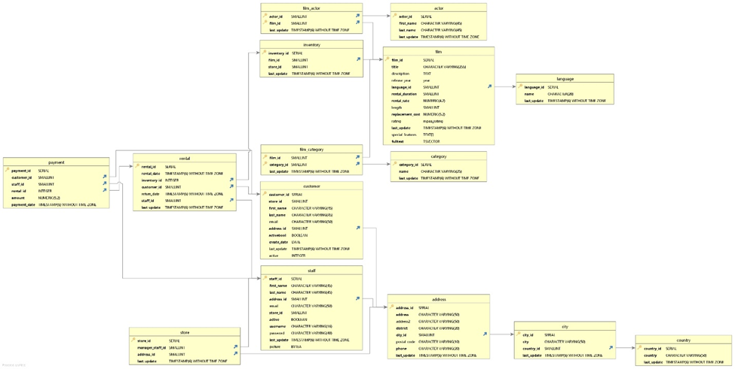

Facts Table:

Rental table

|  |  |  |  |
| --- | --- | --- | --- |
| Keys | Column | Data Type | Description |
| Primary Key | rental_id | Serial | Unique id given to each movie rental |
|  | rental_date | Timestamp without time zone | Date and time the movie was rented |
| Foreign Key | inventory_id | Integer | ID given for record keeping |
| Foreign Key | customer_id | smallint | customer id to whom the movie was rented by |
|  | return_date | Timestamp without time zone | Date and time the movie was returned |
| Foreign Key | staff_id | Smallint | ID assigned to specific employee |
|  | last_update | Timestamp without time zone | Time and date of most resent update |

**Dimension Tables**

Payment table

|  |  |  |  |
| --- | --- | --- | --- |
| Keys | Column | Data Type | Description |
| Primary Key | payment_id | Serial | id assigned to each payment |
| Foreign Key | customer_id | Smallint | customer id to whom the movie was rented by |
| Foreign Key | staff_id | Smallint | Id assigned to specific employee |
| Foreign Key | rental_id | Integer | Unique id given to each movie rental |
|  | amount | Numberic | Amount paid by customer |
|  | payment_date | Timestamp without time zone | Time and date of payment |

Film actor table

|  |  |  |  |
| --- | --- | --- | --- |
| Keys | Column | Data Type | Description |
| Primary Key and Foreign Key | actor_id | Smallint | Unique id given to each actor |
| Primary Key and Foreign Key | film_id | Smallint | Unique id given to each movie |
|  | last_updated | Timestamp without time zone | Time and date of most resent update |

Inventory Table

|  |  |  |  |
| --- | --- | --- | --- |
| Keys | Column | Data Type | Description |
| Primary Key | inventory-id | Serial | id given for record keeping |
| Foreign Key | film_id | Smallint | Unique id given to each movie |
|  | store_id | Smallint | Unique id given to each store |
|  | last_update | Timestamp without time zone | Time and date of most resent update |

Actor Table

|  |  |  |  |
| --- | --- | --- | --- |
| Keys | Column | Data Type | Description |
| Primary Key | actor_id | Serial | Unique id given to each actor |
|  | first_name | Character Varying | First name of actor |
|  | last_name | Character Varying | Last name of actor |
|  | last_update | Timestamp without time zone | Time and date of most resent update |

Language Table

|  |  |  |  |
| --- | --- | --- | --- |
| Keys | Column | Data Type | Description |
| Primary Key | language_id | Smallint | Unique id given to language(s) movies come in |
|  | name | Character Varying | Name of language |
|  | last_update | Timestamp without time zone | Time and date of most resent update |

Film Table

|  |  |  |  |
| --- | --- | --- | --- |
| Keys | Column | Data Type | Description |
| Primary Key | film_id | Serial | Unique id given to each movie |
|  | title | Character Varying | Title of movie |
|  | description | Text | What movie is about |
|  | release_year | Year | Year movie was released |
| Foreign Key | language_id | Smallint | Unique id given to language(s) movies come in |
|  | rental_duration | Smallint | Length of time the movie is rented for |
|  | rental_rate | Numeric | Price to rent movie |
|  | length | Smallint | How long movie is |
|  | replacement_cost | Numeric | Price to replace movie if lost, destroyed, of theft |
|  | rating | mpaa_rating | Movie rating |
|  | last_update | Timestamp without time zone | Time and date of most resent update |
|  | special_feature | Text | Any special features available for movie, HD |
|  | fulltext | Tsvector | Key words |

Film Category

|  |  |  |  |
| --- | --- | --- | --- |
| Keys | Column | Data Type | Description |
| Primary Key and Foreign Key | film_id | Smallint | Unique id given to each movie |
| Primary Key and Foreign Key | category-id | Smallint | Unique id given to each type of movie category |
|  | last_updated | Timestamp without time zone | Time and date of most resent update |

Category

|  |  |  |  |
| --- | --- | --- | --- |
| Keys | Column | Data Type | Description |
| Primary Key | category_id | Smallint | Unique id given to each type of movie category |
|  | name | Character Varying | Name of language |
|  | last_update | Timestamp without time zone | Time and date of most resent update |

Customer Table

|  |  |  |  |
| --- | --- | --- | --- |
| Keys | Column | Data Type | Description |
| Primary Key | customer_id | Serial | customer ID to whom the movie was rented by |
|  | store_id | Smallint | Unique id given to each store |
|  | first_name | Character Varying | First name of customer |
|  | last_name | Character Varying | Last name of customer |
|  | email | Character Varying | Email address of customer |
| Foreign Key | address_id | Smallint | Postal ID of customer |
|  | activabool | Boolean | Status if customer is active or not |
|  | create_data | Date | Creation date |
|  | last_update | Timestamp without time zone | Time and date of most resent update |
|  | active | Integer | Customer status |

Store Table

|  |  |  |  |
| --- | --- | --- | --- |
| Keya | Column | Data Type | Description |
| Primary Key | store_id | Serial | Unique ID given to each store |
| Foreign Key | manager_staff_id | Smallint | ID of manager |
| Foreign Key | address_id | Smallint | Postal ID of customer |
|  | last_update | Timestamp without time zone | Time and date of most resent update |

Staff Table

|  |  |  |  |
| --- | --- | --- | --- |
| Keys | Column | Data Type | Description |
| Primary Key | Staff_id | Serial | Unique ID given to each employee |
|  | first_name | Character Varying | First name of staff |
|  | last_name | Character Varying | Last name of staff |
| Foreign Key | address_id | Smallint | Postal ID of staff |
|  | email | Character Varying | Email address of staff |
|  | store_id | Smallint | Unique ID given to each store |
|  | active | Boolean | Staff status |
|  | username | Character Varying | Username of Staff |
|  | password | Character Varying | Password of Staff |
|  | last_update | Timestamp without time zone | Time and date of most resent update |
|  | picture | BYTEA | Picture of staff |

Address Table

|  |  |  |  |
| --- | --- | --- | --- |
| Keys | Column | Data Type | Description |
| Primary Key | address_id | Serial | Postal address of store |
|  | address | Character Varying | Postal address of store |
|  | address2 | Character Varying | Postal address of store |
|  | district | Character Varying | Time and date of most resent update |
| Foreign Key | city_id | Smallint | City |
|  | postal_code | Character Varying | Postal code |
|  | phone | Character Varying | Phone number |
|  | last_update | Timestamp without time zone | Time and date of most resent update |

City Table

|  |  |  |  |
| --- | --- | --- | --- |
| Keys | Column | Data Type | Description |
| Primary Key | city_id | Serial | Unique ID given to Cities |
|  | city | Character Varying | City |
| Foreign Key | country_id | Smallint | Unique ID give to each Country |
|  | last_updated | Timestamp without time zone | Time and date of most resent update |

Country Table

|  |  |  |  |
| --- | --- | --- | --- |
| Keys | Column | Data Type | Description |
| Primary Key | country_id | Serial | Unique ID give to each Country |
|  | country | Character Varying | Country |
|  | last_updated | Timestamp without time zone | Time and date of most resent update |